SASKATCHEWAN’S CHARITY
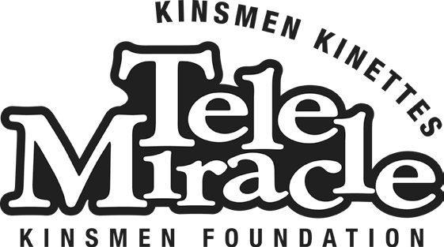
Kinsmen Foundation Inc.
2217C Hanselman Court Saskatoon, SK S7L 6A8 Phone: 306-244-6400 EXT 1 Toll Free:1-877-777-8979
Fax: 306-653-5730
INDIVIDUAL REQUEST FOR FUNDING - WORKSHEET

If you have any questions regarding your application, please contact Geneen at: kin.geneen@telemiracle.com 306-244-6400 (ext 1)

Please use this checklist to ensure that you have included all the required documents.

Providing all the relevant documents at the time you submit your application will ensure that your request is processed without delay. Incomplete applications will not be considered. This checklist does not have to be submitted.

Eligibility
- Applicants must provide a valid Saskatchewan Health Card number AND be a Canadian Citizen or Permanent Resident of Canada.
  - The Board will accept applications from individuals who live in border communities (such as Lloydminster or Flin Flon) who do not hold a Saskatchewan Health Card.
- If you have lived in Saskatchewan for less than 5 years, please submit one of the following documents:

- Canadian Birth Certificate
- Canadian Passport
- Certificate of Indian Status
- Certificate of Citizenship
- Permanent Resident Card

The Kinsmen Foundation reserves the right to request proof of Canadian Citizenship or Canadian permanent residency at any time.

Tax Information
- T1 Generals are required from applicants 19 years of age and up, their spouse or common-law partner OR applicants 18 years of age and not living with parents.
- You are required to submit your most recent T1 General (also called Tax Summary or Proof of Income) that you have filed with the Canada Revenue Agency (CRA). The T1 General will verify income from all sources. This is the most accurate representation of your actual income.
REQUIRED:
  - Applicant’s T1 General
  - Spouse/Partner’s T1 General

IF APPLICABLE to your situation:
  - Farm Income
- Kinsmen Foundation Farm Form
- Schedule B- CRA Statement of Farming Activities
  - Social Services (income assistance, SAID program)
    - 2 months of recent statements

Equipment Requests
Equipment applications require a letter of recommendation & Kinsmen Foundation form from the professional assisting you, as your equipment will require some specific adaptations for your needs.

  - Occupational therapist (OT)
  - CNIB support professional
  - Audiologist

  - Speech language pathologist (SLP)
  - Other: _________________________

Medical Travel Request
Medical travel requests require a letter of support from your Medical Social Worker.

Letter of support from your Medical Social Worker

- Equipment Quotes
Equipment applications require a quote for each piece of equipment from two separate vendors (businesses). These quotes may be secured by you or the medical professional assisting you. The Kinsmen Foundation Board of Directors makes their decision regarding equipment based on a number of factors, with trialing being only one of them. Please have quotes send directly to the office.

Quote #1
  - Quote #2

- Landlord Waiver Form
If you are living in a rental property or a condo, whereby you need permission to make changes to the structure, please complete this form. Examples include having equipment installed such as, stair lifts, ceiling tracks, indoor and outdoor lifts, widening of doorways or ramps require changes to the structure.

Kinsmen Foundation Landlord Waiver Form

- Complete & Submit Your Application Online
We have transitioned to an online application process, so we are asking that anyone with an email address (or a support person) complete the online application.
- Go to www.telemiracle.com/funding-info-application/ and select the “Click here to apply for funding” button.
- Create an account
- Complete the form, upload required documents & review
- Submit
o You will receive a 5 digit confirmation ID number via email once you have submitted your application.

Submit your paper application via:
  - Fax: 306-653-5730
  - Email: foundation@telemiracle.com
  - Mail: Kinsmen Foundation Inc.
2217C Hanselman Court Saskatoon, SK S7L 6A8

Thank you for applying to the Kinsmen Foundation!
The Kinsmen Foundation is a non-profit registered charity that provides financial support for accessibility equipment and medical travel to Saskatchewan residents who qualify. Funds to support the grants provided to applicants are raised through the Kinsmen Foundation’s yearly fundraising telethon, TeleMiracle, which is held in February or March each year.

